## AUDIT COURSE

## A REPORT

**ON**

**‘CRITICAL THINKING’**

**CAN WE SAVE OUR PLANET?**

**Submitted By**

**SAKSHI MORE B1751068**

**ABUZAR TAMBOLI B1751075**

**SATYAM JAIMINI B1751088**

**KASTURI POKHARKAR B1751096**

## BACHELOR OF TECHNOLOGY

## 

**[SEMESTER VII]**



### DEPARTMENT OF INFORMATION TECHNOLOGY

### D.Y. PATIL COLLEGE OF ENGINEERING AKURDI, PUNE

### SAVITRIBAI PHULE PUNE UNIVERSITY

**(2020-2021)**

# CONTENTS

CERTIFICATE I

ABSTRACT II

INTRODUCTION III

MAJOR CURRENT ENVIRONMENTAL PROBLEMS 1

IS IT TOO LATE TO SAVE OUR PLANET? 2

IS OUR PLANET DESPERATE? 3

WE HAVE SAVED OUR PLANET BEFORE? 4

CLIMATE FUNDS ARE FLOWING! 5

SAVING THE PLANET IS DESIRABLE AND FUN 6

CONCLUSIONS 7

REFERENCES 8

# ABSTRACT

*A future in which catastrophic climate change is kept at bay while we still power our developing world. A future in which we can feed 10 billion people worldwide and provide cleaner, more abundant drinking water while also protecting life-giving lands, lakes and rivers. A future in which nature’s wild heart still beats strong through healthy wildlife and magnificent landscapes while our cities are strengthened by harmony with nature.*

*A future in which people and nature thrive together. Science shows us this vision of the future is achievable, and we must join together and put all our effort into the big priorities that will make this vision a reality.*

*Our biggest shared challenge is climate change. If it seems overwhelming, it’s in part because we, as individuals, can’t stop it. Even if we’re perfect green consumers—refusing to fly, reusing shopping bags, we’re trapped in a system that makes it impossible to stop adding to the problem. Living requires eating, getting to work, and staying warm enough in winter and cool enough in summer to work and sleep. For now, it’s impossible to do these things in most places without emitting carbon.*

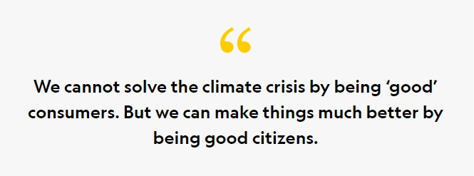

**INTRODUCTION**

Our environment is constantly changing. There is no denying that fact. However, as our environment changes, so does the need to become increasingly aware of the problems that surround it. With a massive influx of natural disasters, warming and cooling periods, different types of weather patterns and much more, people need to be aware of what types of environmental problems our planet is facing.

Global warming has become an undisputed fact about our current livelihoods; our planet is warming up and we are definitely part of the problem. However, this isn’t the only environmental problem that we should be concerned about. All across the world, people are facing a wealth of new and challenging environmental problems every day. Some of them are small and only affect a few ecosystems, but others are drastically changing the landscape of what we already know.

Our planet is poised on the brink of a severe environmental crisis. Current environmental problems make us vulnerable to disasters and tragedies, now and in the future.

We are in a state of planetary emergency, with environmental problems piling up high around us. Unless we address the various issues prudently and seriously, we are surely doomed for disaster. Current environmental problems also require urgent attention.

**MAJOR CURRENT**

**ENVIRONMENTAL PROBLEMS**

**1. Pollution**

There are 7 key types of pollution – air, water, soil, noise, radioactive, light and thermal and these are primary causes that affect our environment in many ways. All these types of pollution are interlinked and influence each other. Therefore we need to tackle all of them together.

**2. Soil Degradation**

Globally, food security depends on the factor whether or not soils are in good condition to produce crops. According to UN estimates, about 12 million hectares of farmland a year get seriously degraded.

Soils get damaged due to many reasons. Such reasons include erosion, overgrazing, overexposure to pollutants, monoculture planting, soil compaction, land-use conversion and many more.

Nowadays, a wide range of techniques of soil conservation and restoration exist, from no-till agriculture to crop rotation to water-retention through terrace-building.

**3. Global Warming**

Climate changes like global warming are the result of human practices like the emission of greenhouse gases. Global warming leads to rising temperatures of the oceans and the earth’ surface causing natural disasters that include flooding, melting of polar ice caps, rise in sea levels and also unnatural patterns of precipitation such as flash floods, hurricanes, wildfires, drought, excessive snow or desertification.

**4. Natural Resource Depletion**

Another crucial current environmental problem is the depletion of Natural resources. We, humans, use so many natural resources that it would need almost 1.5 Earths to cover all our needs.

This will further increase in the future due to massive industrialization in Asian countries like India and China. Increased use of natural resources leads to a number of other environmental issues, such as industrialization, population growth and air pollution.

**5. Deforestation**

Our forests are natural sinks of carbon dioxide and produce fresh oxygen, as well as help in regulating temperature and rainfall. At present, forests cover 30% of the land, but every year tree cover is lost, amounting to the country of Panama due to the growing population demand for more food, shelter and cloth. Deforestation simply means clearing of green cover and making that land available for residential, industrial or commercial purposes.

**6. Climate Change**

Climate change is yet another environmental problem that has surfaced in the last couple of decades. It occurs due to the rise in global warming, which happens due to the increase in temperature of the atmosphere by burning fossil fuels and the release of harmful gases by industries.

Climate change has various harmful effects but is not limited to the melting of polar ice, change in seasons, occurrence of new diseases, frequent occurrence of floods and change in overall weather scenario.

**7. Ozone Layer Depletion**

The ozone layer is an invisible layer of protection around the planet that protects us from the sun’s harmful rays. The depletion of the crucial Ozone layer of the atmosphere is attributed to pollution caused by Chlorine and Bromide found in Chloro-fluoro carbons (CFCs). Once these toxic gases reach the upper atmosphere, they create a hole in the ozone layer, the biggest of which is above the Antarctic.

CFCs are banned in many industries and consumer products. The ozone layer is valuable because it prevents harmful UV radiation from reaching the earth. This is one of the most important current environmental problems.

**8. Acid Rain**

Acid rain occurs due to the presence of certain pollutants in the atmosphere. Acid rain can be caused due to combustion of fossil fuels or erupting volcanoes or rotting vegetation which releases sulfur dioxide and nitrogen oxide into the atmosphere.

Acid rain is a known environmental problem that can have a serious effect on human health, wildlife and aquatic species.

**IS IT TOO LATE TO SAVE OUR PLANET?**

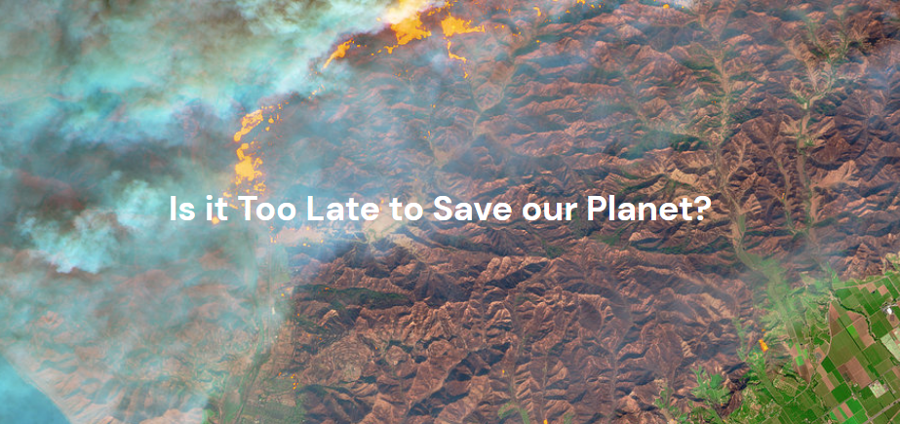

In a 2018 report by the IPCC, it was stated that 12 years are left to turn the fight against climate change around. Other sources quoted the much more stringent deadline of 18 months. Some bleaker minds say it is already too late to fight the effects of climate change, and yet other analyses point out numerous thresholds and therefore cannot give a precise doomsday deadline.

So, how much time is left to save our planet really? Is there an actual tipping point to our planet? Whether you call it global warming, Anthropocene or climate crisis, humans are not programmed for long-term, slow crises. We just know how to think (and/or run) real fast when chased by an angry grizzly bear, but climate change is coming at humans from a deadly angle. The slow burn angle.

**IS OUR PLANET DESPERATE?**

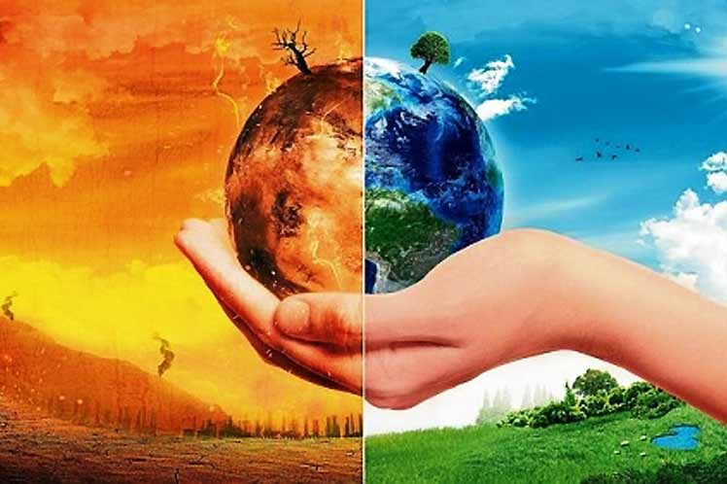

This planet as we know it is the product of a delicate equation between the mineral structure of Earth – for example, the atmosphere’s composition – and its biosphere – trees absorbing CO2 and pumping O2 through photosynthesis. It is established that vegetation, from microplankton to majestuous sequoia trees, was the dominant cause of changes to the atmosphere’s chemical composition.

Mammals and other oxygen-breathing species (these guys…) came long after the groundwork had happened. By then, most land that was not frozen or desert was forested. The time was ripe for another species to try its hand at shaking the world to its foundation. First by cutting down most of its life support system, and by pumping back into the atmosphere the carbon that had been patiently trapped within organic matter and into the ground.

Humans have an advantage over trees though. We have taken notice of the transformation. And we are trying to do something about it. What is our timeline? We are uncertain because it depends on our own choices. Each day, our steering towards a more sustainable environment pushes the deadline back, and each molecule of CO2 we release into the air draws it closer. Here is why now is not a good time to give up. Especially not now.

**WE HAVE SAVED OUR PLANET BEFORE**

The carbon concentration in our atmosphere is only one of the ways we negatively affect our planet. In the early 1980s, it came to climate scientists’ attention that certain aerosol gasses contained in our sprays damaged permanently the now-famous ozone layer of our atmosphere. Following emergency meetings and the landmark Montreal Protocol, the components that destroyed the ozone layer have been almost entirely removed from circulation in less than 30 years. The proactivity of governments on this issue was key in forging this strategy.

On a continental scale, the EU countries focused on cutting carbon emissions by 22% from 1990 levels. The EU has set ambitious targets for the environment. They consider it as much a necessity as it is an opportunity to become more resilient, more independent, and better off than before.

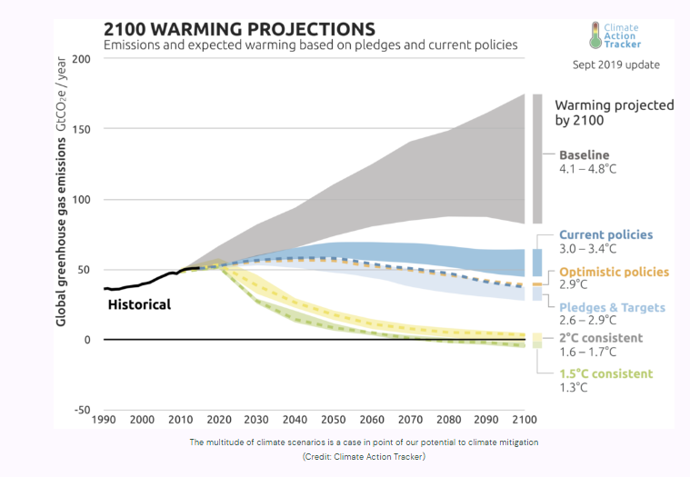

# CLIMATE FUNDS ARE FLOWING!

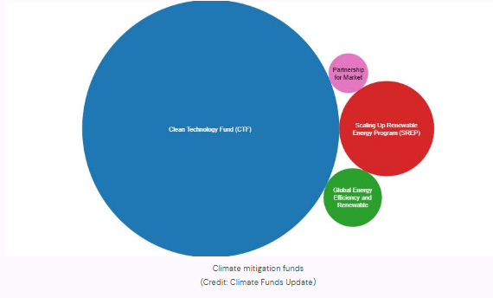

The tide is turning. In the steps of pioneers, the business models and ways to think about the products are changing. Large international groups and local businesses alike integrate corporate sustainability into their decision making. In 2015, IKEA was declaring a €1.16 billion investment to become a net producer of energy by 2020. In the meantime, one of our team members’ hometown Chevreuse was launching a local currency to fund a real green economy in the region.

**What are Businesses doing for climate change?**

Business attitudes have a direct impact on all aspects of climate change. Business sustainability strategies such as sourcing eco-friendly products, green working spaces that produce energy, or simply investing in the green economy: they all contribute to make the planet a greener place, and they are happening. That is what Plan A works on: accompanying companies on their journey to put sustainable solutions into practice by providing a carbon footprint calculator, climate action plans and positive messaging to the fight. One thing is certain: we won’t win the fight against climate change without transforming profoundly the way we do business and how we allocate resources.

# SAVING THE PLANET IS DESIRABLE AND FUN

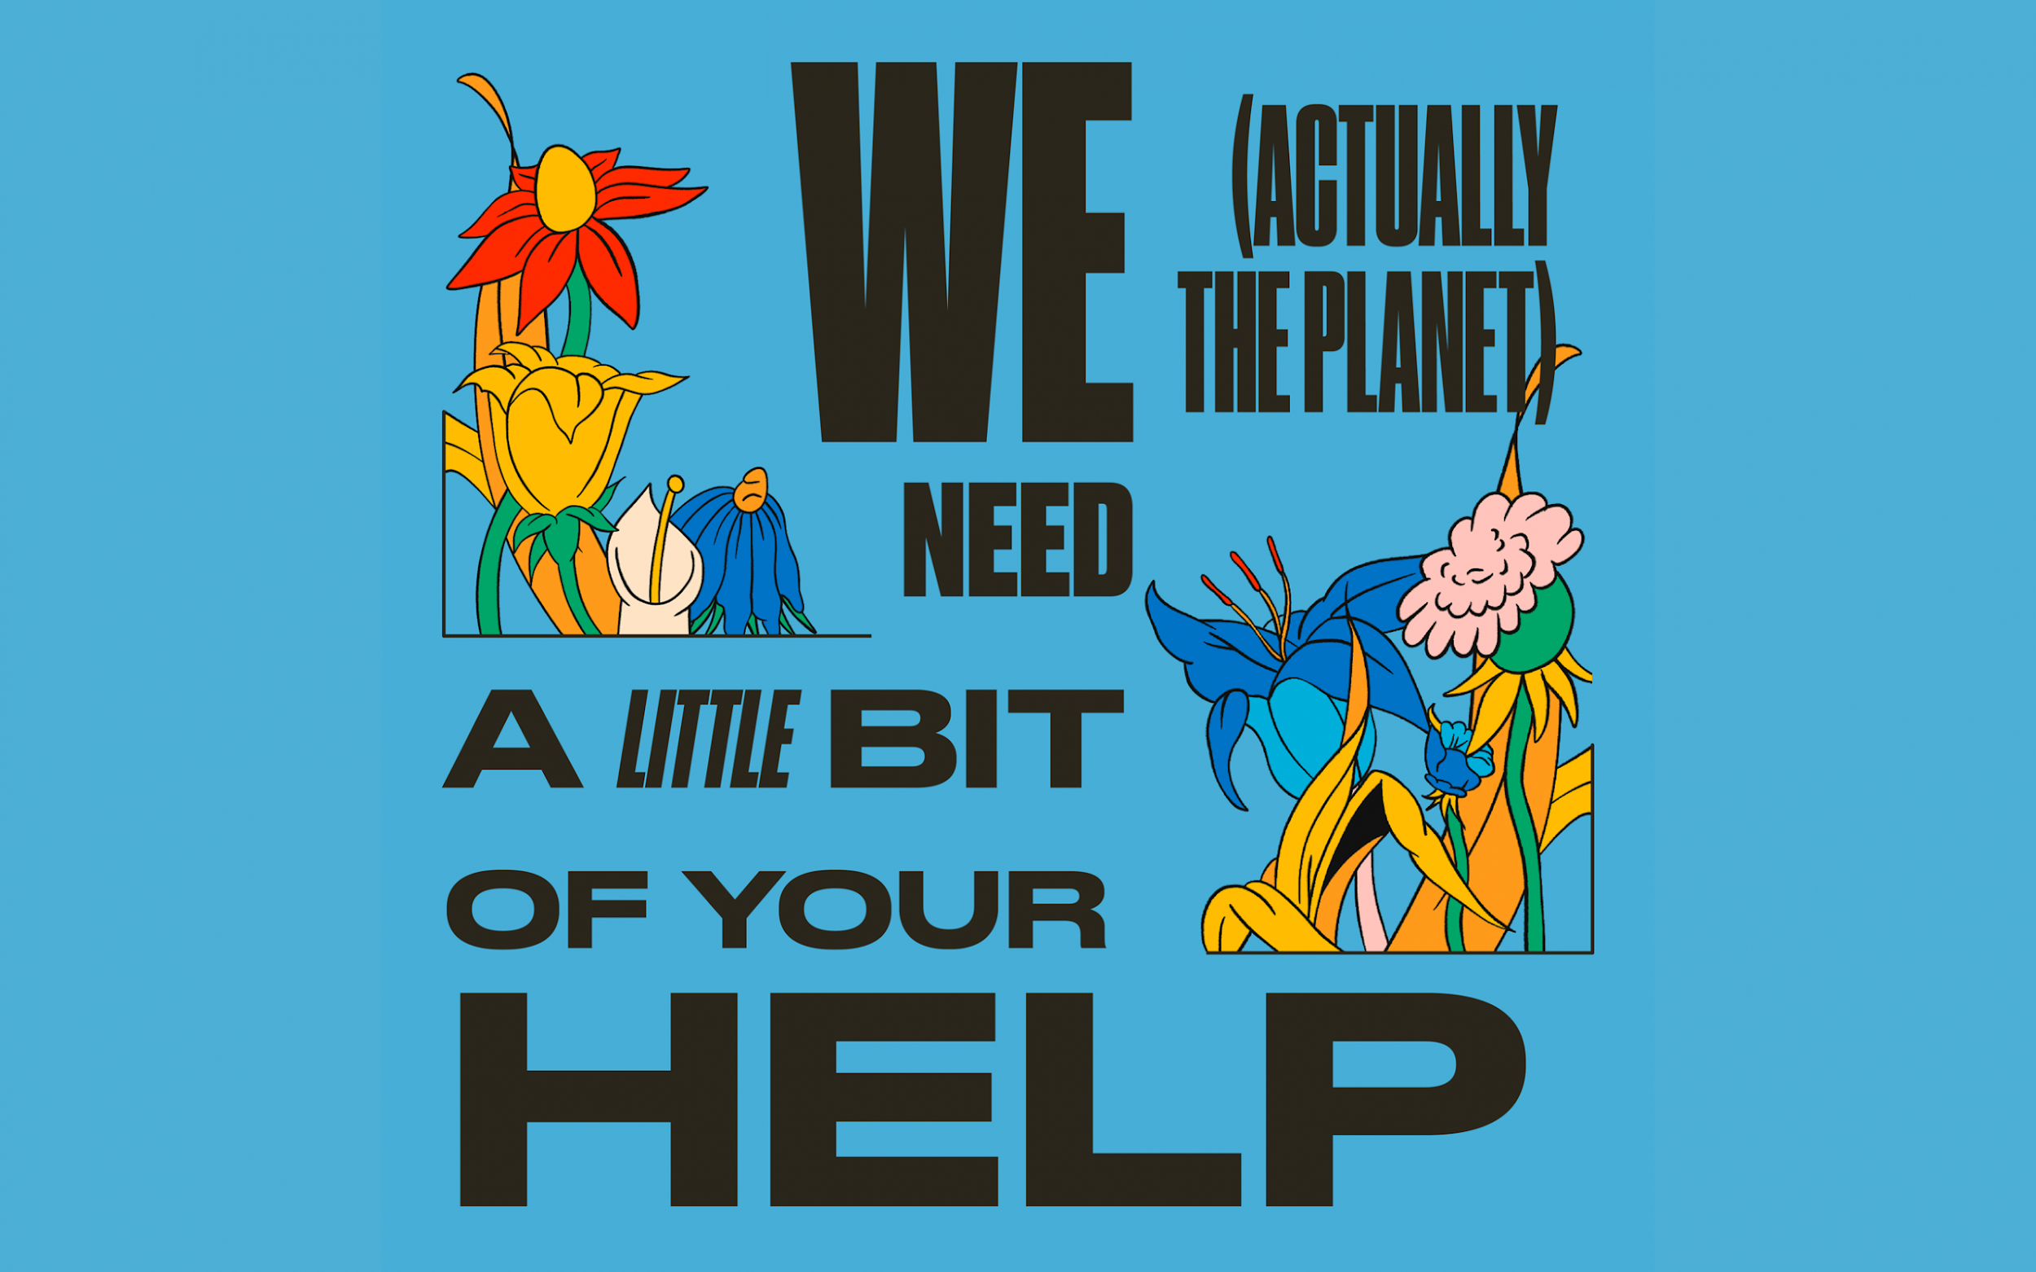

# A sustainable future is desirable. Bike riding is nice. Clean rivers in which to jump in during heatwaves are also a plus. The more we act towards this scenario, the more motivated people will be, rather than afraid of our increasing discomfort with our home planet. Plan A strives to make climate action and sustainable solutions fun and accessible. Come to one of our events one of these days to learn something about climate change, meet interesting people executing climate action plans, and having fun along the way.

# Becoming sustainable is more like a virtuous circle than a rat race. The vision of a thrifty, austere, insect-eating future is not the best pitch to mobilise crowds and engage people on this journey. However, that of pollution-free cities, healthy humans and ecosystems and a thriving new economy are. That is the real political vision behind the transition to a sustainable future. Also, it is a realisable vision on a short enough timeline.

# We have overstepped more than one planetary boundary already. The thing is that there is no real limit to the worst-case scenario. But we can reverse the processes responsible for the climate crisis as fast as we have developed them. Sure, this is the work of a generation, maybe even more. The effects of climate change will not wither away overnight. But we have the future in our hands, and that is all we need to know to push for this future.

**CONCLUSION**

Save the earth is a very real campaign for everyone. Everyone has to take responsibility for protecting the land because it is our land and we are living on this earth. So it becomes our responsibility to take care of it. We should make all things which can save the land because the future generation also needs the right and good earth. If everyone takes the proper step for the earth then never earth will be down. Consequently, the earth will always be safe.

**SAVE THE WATER**

We always pay attention during the uses of water because water is life. We should use water in a limited way and make it a routine of daily life. It can make a big difference by these little things. Don’t waste the water unnecessarily because it can be less for the future generation.

**REDUCE GREENHOUSE GASES**

If you can stay off the road just two days a week, then you should leave your car at home. Combine your errands during the post office, grocery store and shoe repair place in one trip so that it can save you gas and time. You can also reduce the greenhouse gasses while burning some calories and improving your health.

**REDUCE ENVIRONMENTAL POLLUTION**

We can also reduce the pollution just by putting that soda can in a different bin. If you’re trying to choose between two products, pick the one with the least packaging. If an office building of 7,000 workers recycled all of its office paper waste for a year, it would be the equivalent of taking almost 400 cars off the road

**SAVE TREES**

We should save the trees and make the trees save the earth. The schemes afforestation and reforestation should wholeheartedly support.

**REDUCE THE AMOUNT OF SOLID WASTE**

Due to the cutting of solid waste, you can stop the trash which you make in a year. The use of solid waste can harm the land, and it was taking up less space in landfills.

**SAVE NATURAL VEGETATION**

We can keep the natural vegetation during the use of less paper. We can make arrangements for recycling of used paper and other natural products. It is vital because the plants and trees cover and hold the planet earth.

**SAVE NATURAL RESOURCES**

We all know that the supply of natural resources such as minerals, stones, coal, oil, etc. are limited. We can save electricity by putting off the lights when not in use. Or we can switch to fans instead of air conditioners during nights.

**SAVE ENVIRONMENTAL POLLUTION**

We should not pollute water by not throwing wastes into water to save the earth because it can become very critical for the earth. We should minimize air pollution by reducing harmful emissions. Use fewer cars, fewer machines, less electricity, and less plastic goods. Eat organic foods.

**STOP THE GLOBAL WARMING**

In the industrial area, the people should check their machines regularly because it will be helpful in reducing global warming. If machines are emitting smokes within permissible limits, then it should be checked and repaired automatically. It ensures the discharge only after treatment.

**SAVE ENERGY OF THE EARTH**

Make your home more energy efficient (and save money). Clean your air filters, so your system doesn’t have to work overtime. Get a programmable thermostat, so you aren’t wasting energy when you aren’t home. Turn off lights when you’re not in the room and unplug appliances when you’re not using them. It only takes a second to be environmentally conscious.

**REFERENCES**

* <https://www.iaspaper.net/save-earth/#:~:text=Conclusion,are%20living%20on%20this%20earth.&text=We%20should%20make%20that%20all,the%20right%20and%20good%20earth>
* <https://plana.earth/academy/is-it-too-late-for-our-planet/>
* <https://www.conserve-energy-future.com/15-current-environmental-problems.php>

## [The Uninhabitable Earth: Life After Warming](https://www.amazon.com/Uninhabitable-Earth-Life-After-Warming/dp/0525576703?ots=1&tag=vogue0d-20&linkCode=w50) by David Wallace-Wells

## [No One Is Too Small to Make a Difference](https://www.amazon.com/One-Too-Small-Make-Difference/dp/014313356X?ots=1&tag=vogue0d-20&linkCode=w50) by Greta Thunberg